Eyelash Extensions!

Eyelash Extensions are a great way to lengthen & add volume to your natural lashes!

Before we start:
Don’t wear any eye make-up to your appointment.
We will decide whether you would like/suit classic or volume lashes best.
I recommend getting an Eyelash Tint beforehand if your natural lashes are fair – this makes the extensions look more natural if all your lashes blend together!

The Process:
After prepping your natural lashes, I cover your bottom lashes. The rest of the time your eyes are closed.
I then attach 1 extension to each of your individual natural lashes.
The process takes approximately an hour for Classic Lashes, 1.5hrs for Volume Lashes.
Eyelash Extensions last approximately a month (this all depends on how they are cared for/what conditions they are subject to) – they just fall out when your natural lashes fall out.

Caring for your new lashes:
Keep your eyes away from water for the first 24hrs, after that swimming and showering is ok.
(Avoid steamy showers/spas.)
Brush your lashes daily. (When dry)
DO NOT touch/rub your eyes!
DO NOT use lash curlers.
Only use oil free make-up removers/lash shampoo’s. (Such as the Graft-A-Lash Remover/Shampoo)
It is not recommended to wear mascara, however, if you must – use a water soluble mascara.
(Such as the Graft-a-Lash Mascara)
Be mindful when using skincare & washing your hair to avoid getting product on your lashes.
Don’t apply pressure to lashes for long periods of time. Eg. Be mindful when sleeping.
DO NOT pull your lashes off if you do not like them or find them irritating, have them removed professionally to avoid damaging your natural lashes.

Maintenance:
I recommend infills every 2/3 weeks to keep your lashes full and luscious!
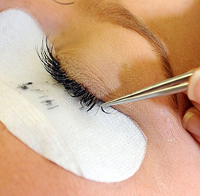
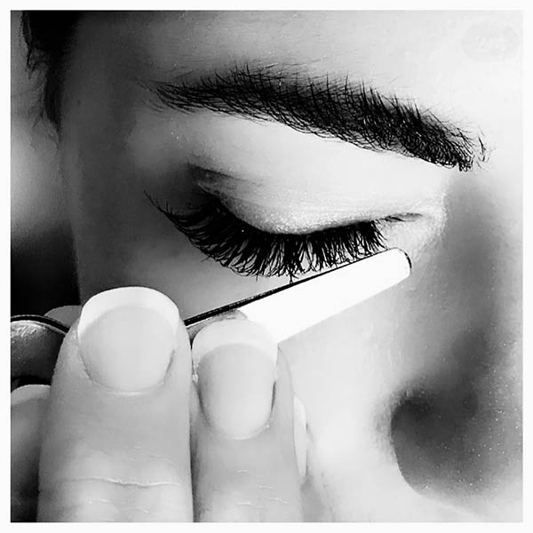
Classic Lashes
Full Set $75
Infills: 2 weeks = $45, 3 weeks = $60

Volume Lashes
Full Set $95
Infills: 2 weeks = $50, 3 weeks = $65


